**EXPERIMENT 8**

**Create a simple cloud web application for a student counseling system using any Cloud Service Provider to demonstrate SaaS with the fields of student name, age, address, phone, subjects studied, Year of passing, percentage of marks, domain interest, etc**

STEP 1: ENTER APPLICATION NAME

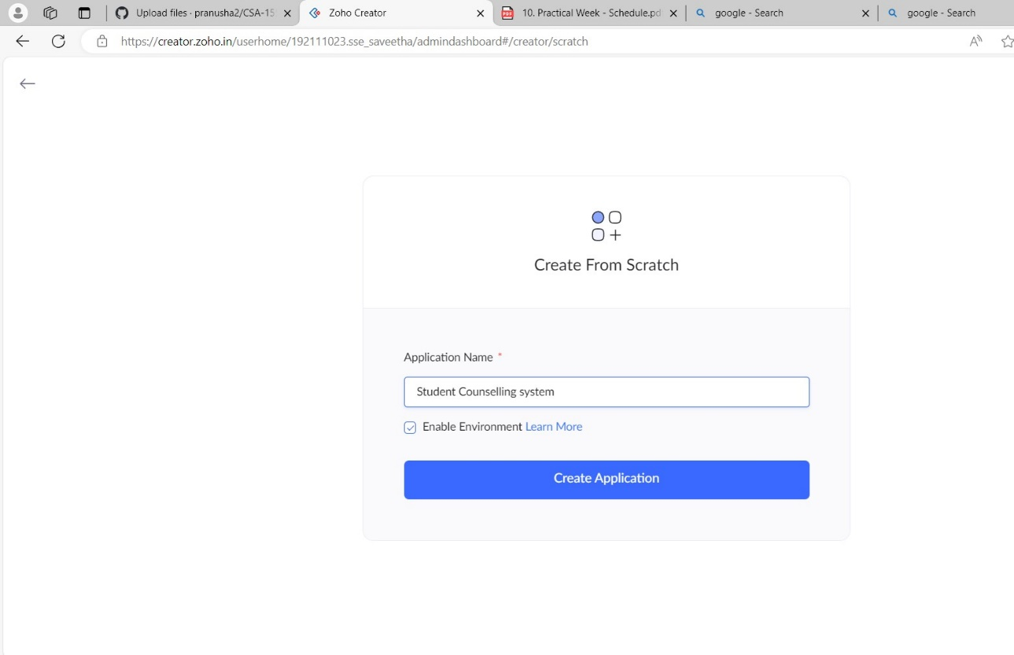

STEP 2: CREATED NEW APPLICATION

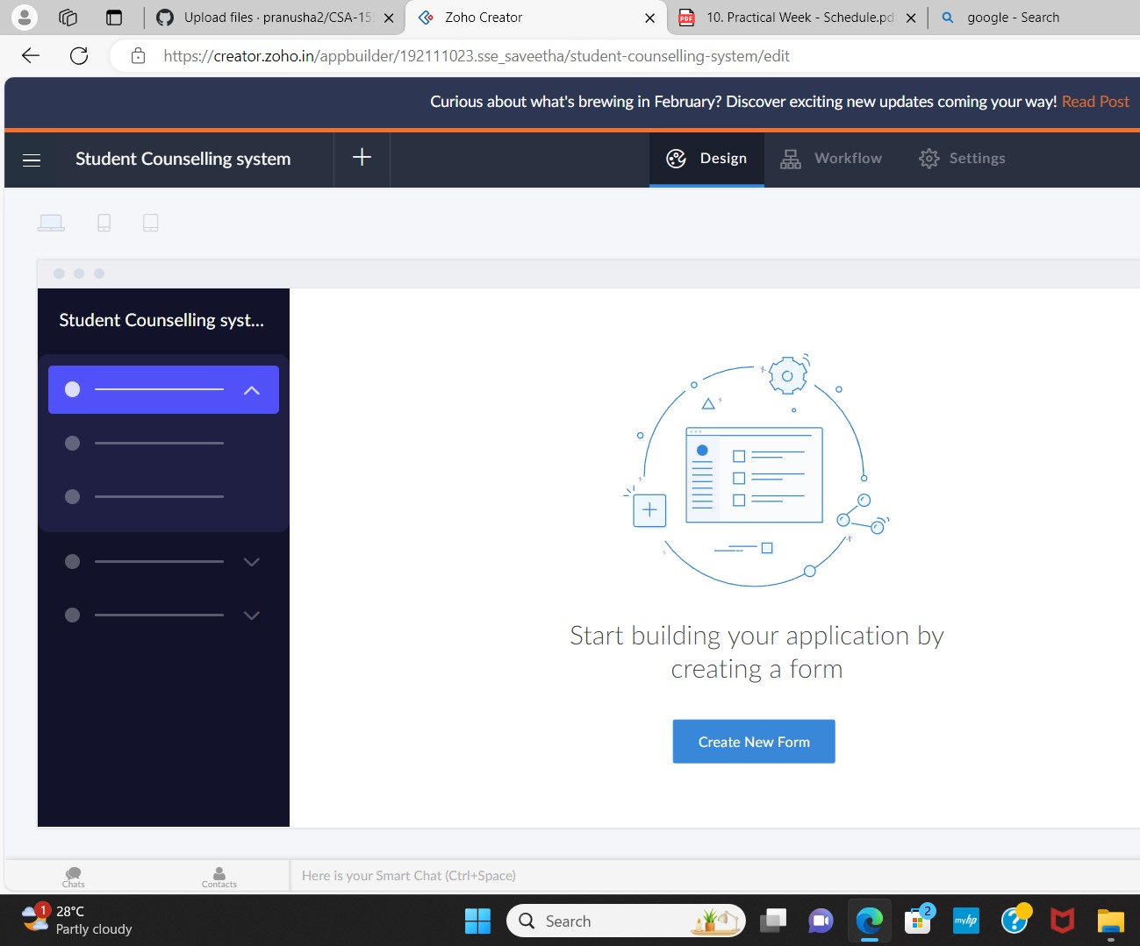

STEP 3: Select from Scratch and Create form as login

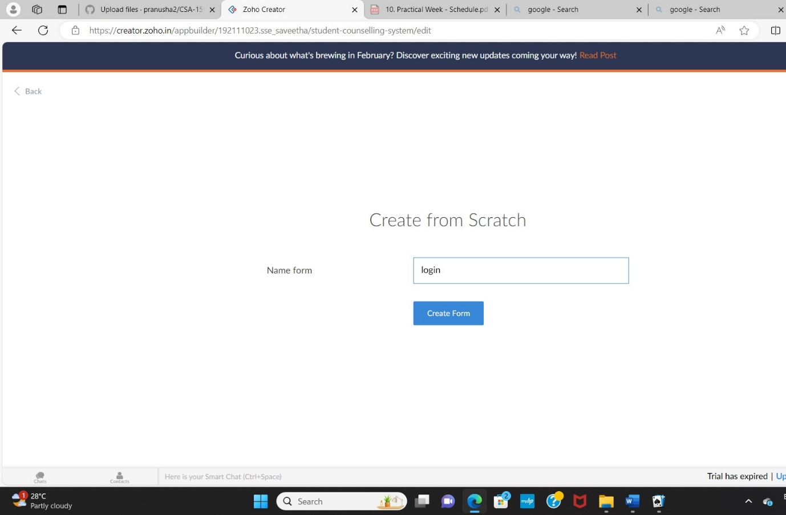

STEP 4: The form has been created as login.

Choose the fields.

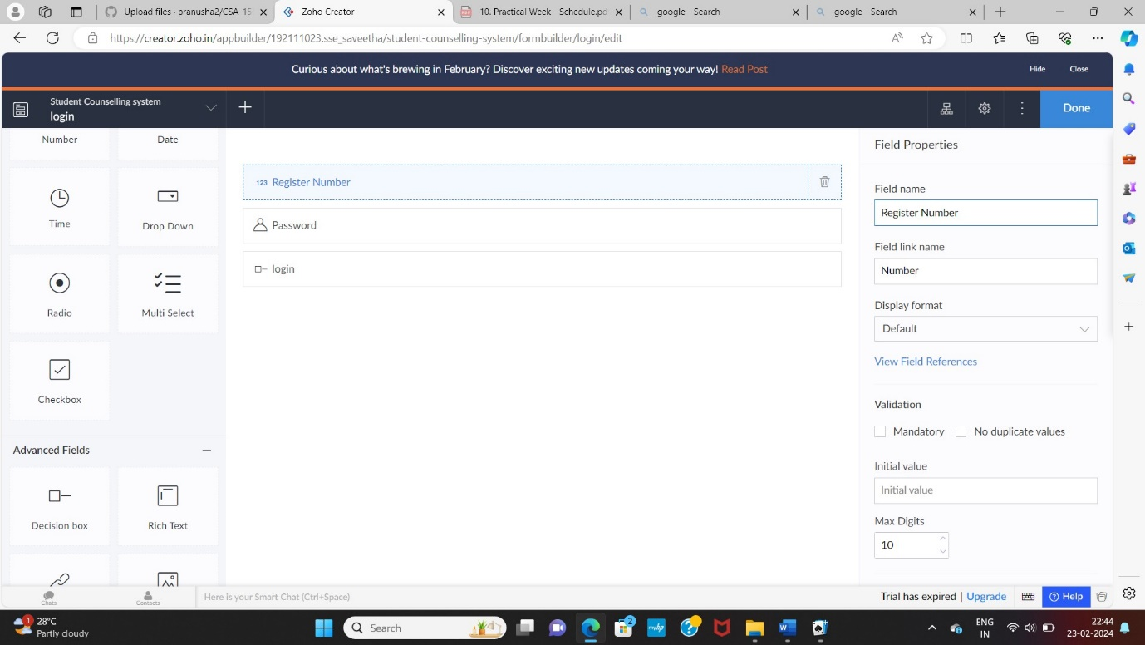

STEP 5: Click Access Development Live and enter the details to access.

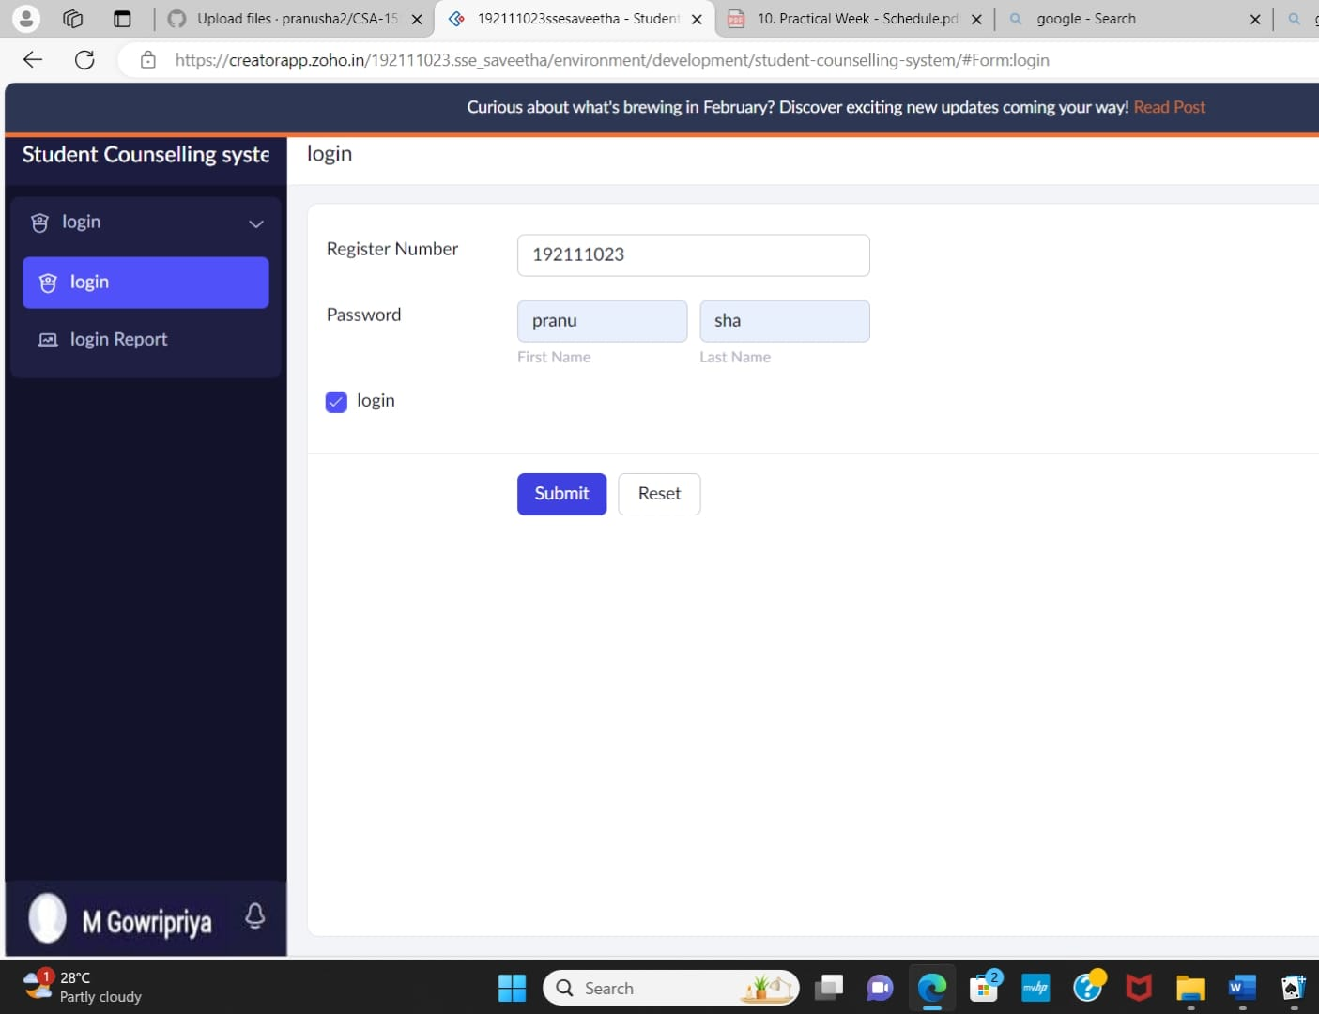

STEP 6: The report has been registered in the login report.

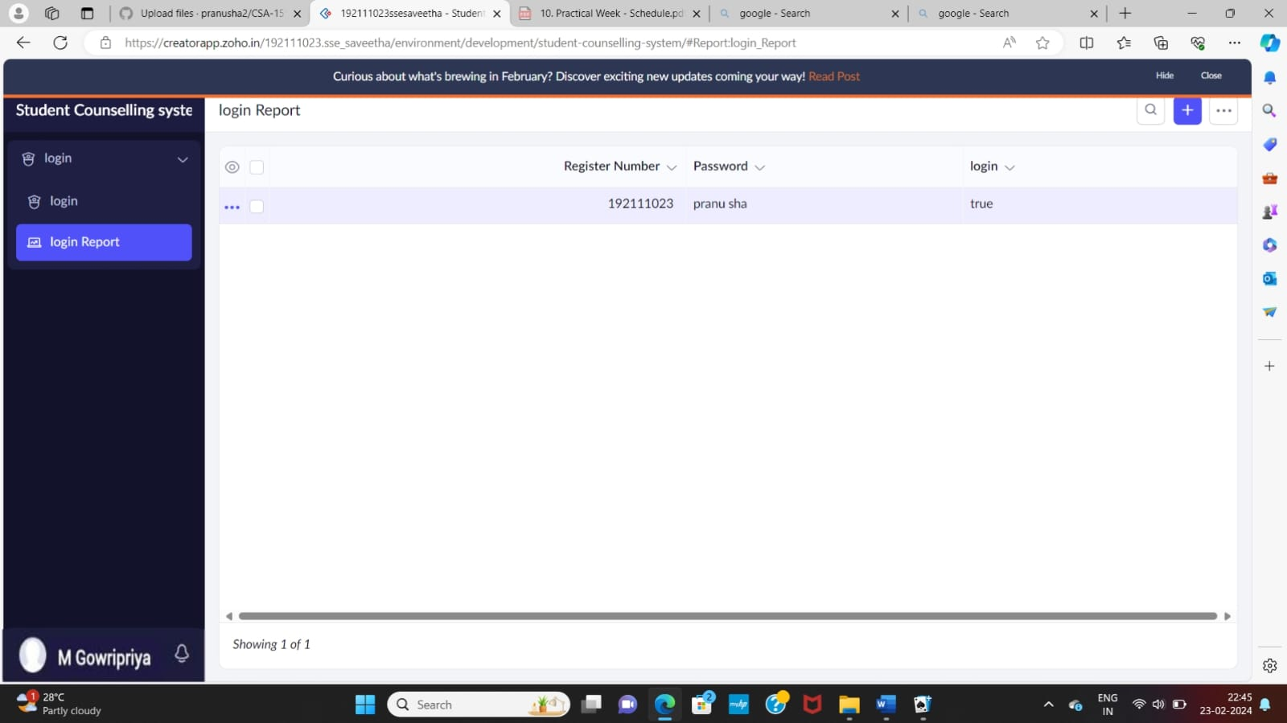

STEP 7: Select from Scratch and Create form as SIMATS.

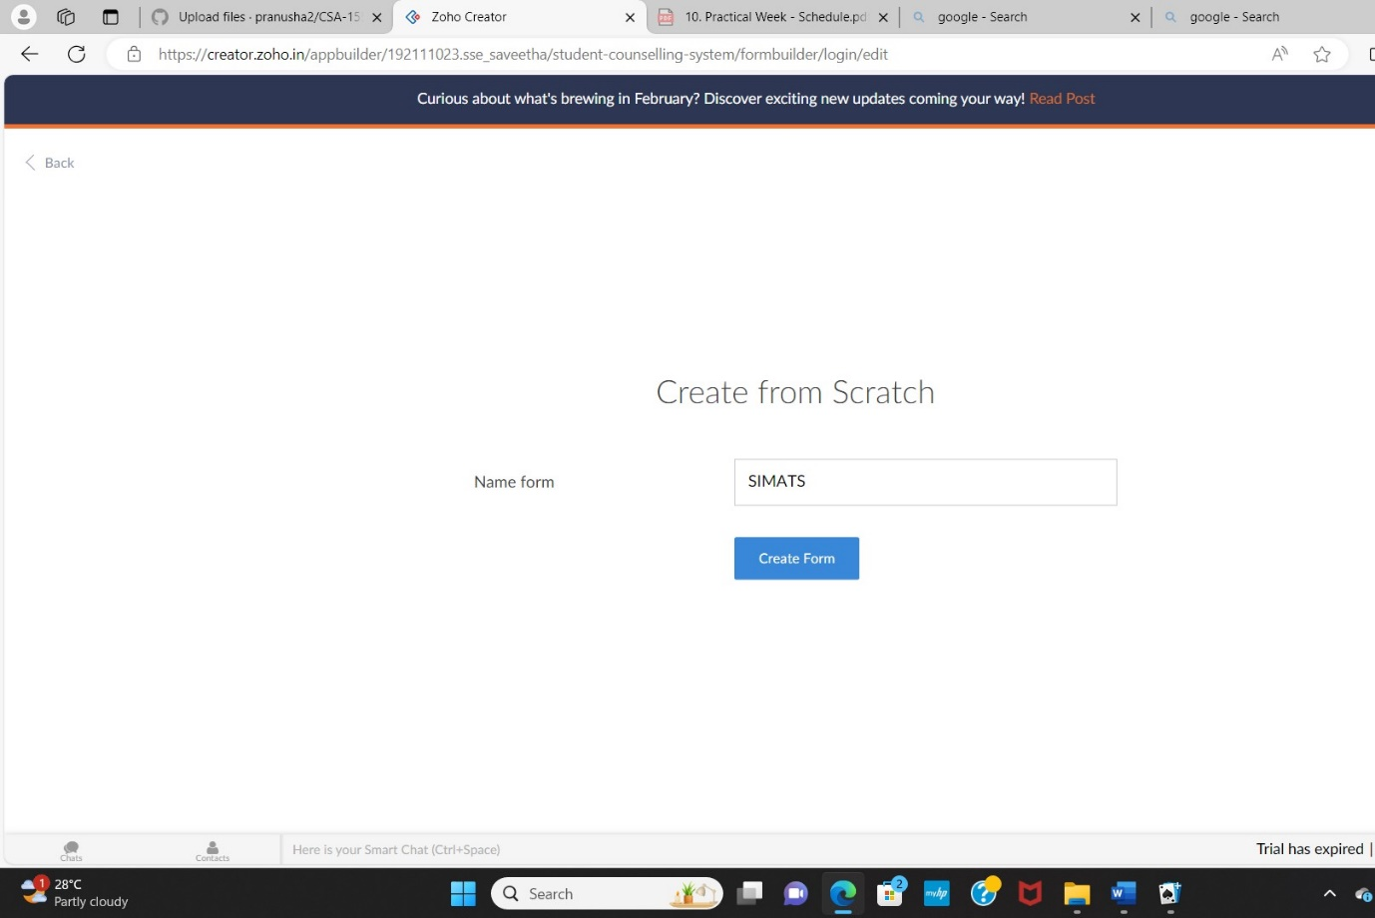

STEP 8: The form has been created as SIMATS.

Choose the fields.

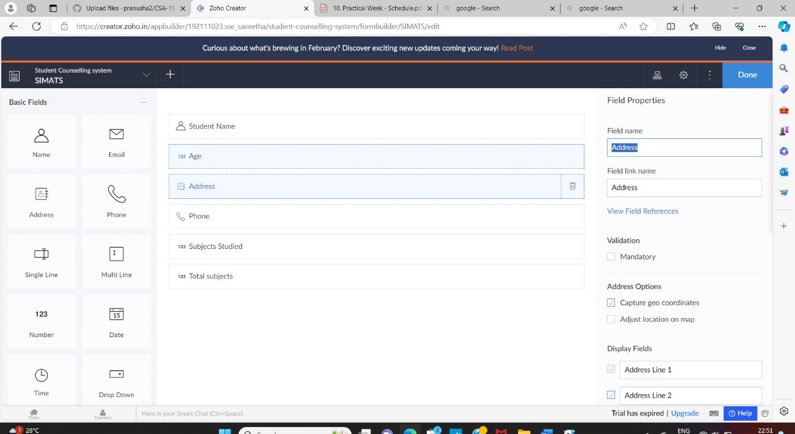

STEP 9: Click Access Development Live and enter the details to access.

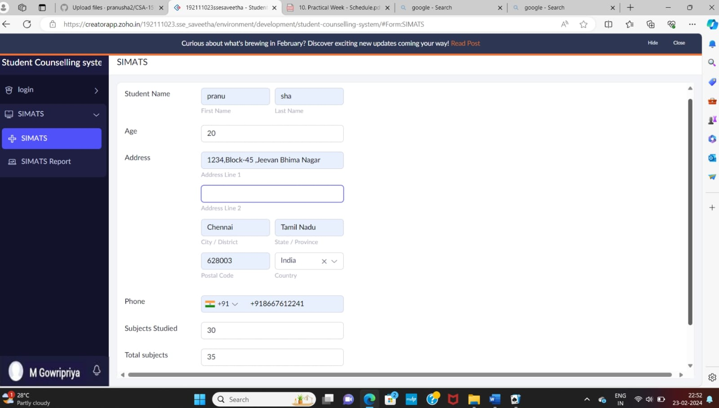

STEP 10: The report has been registered in the SIMATS report.

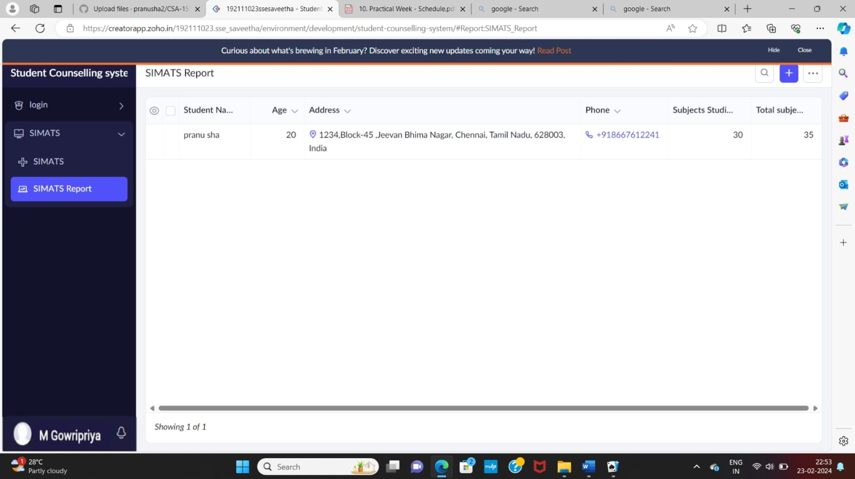

STEP 11: Select from Scratch and Create a form as student details.

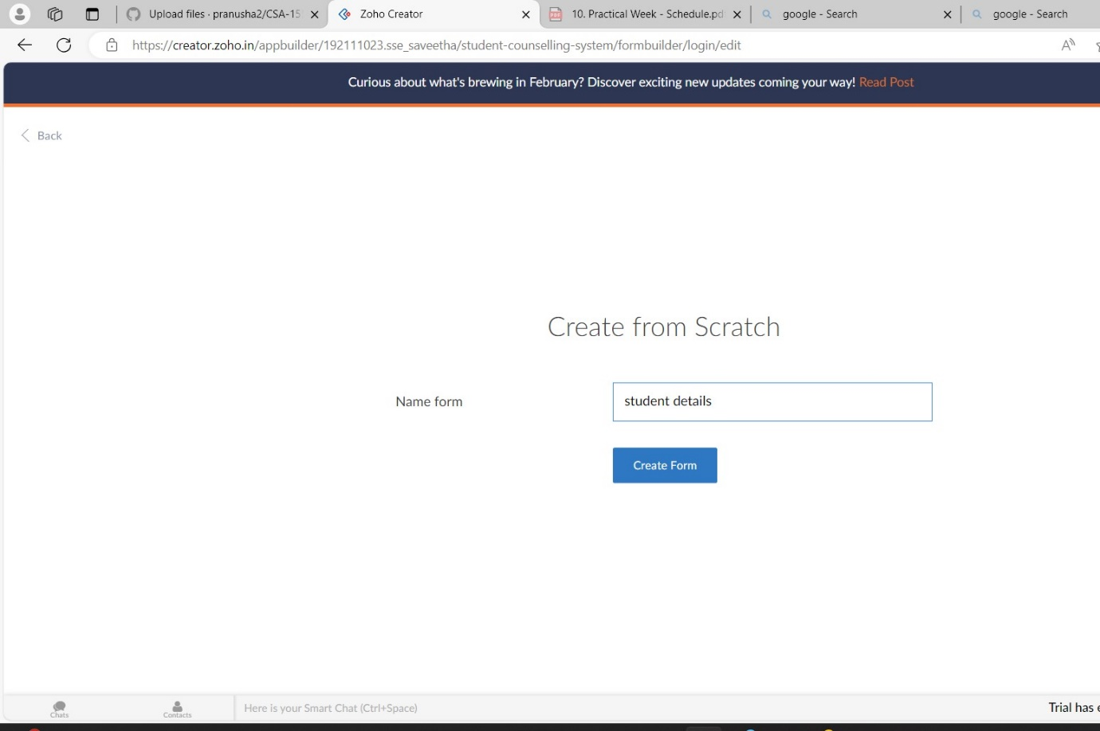

STEP 12: The form has been created as student details.

Choose the fields.

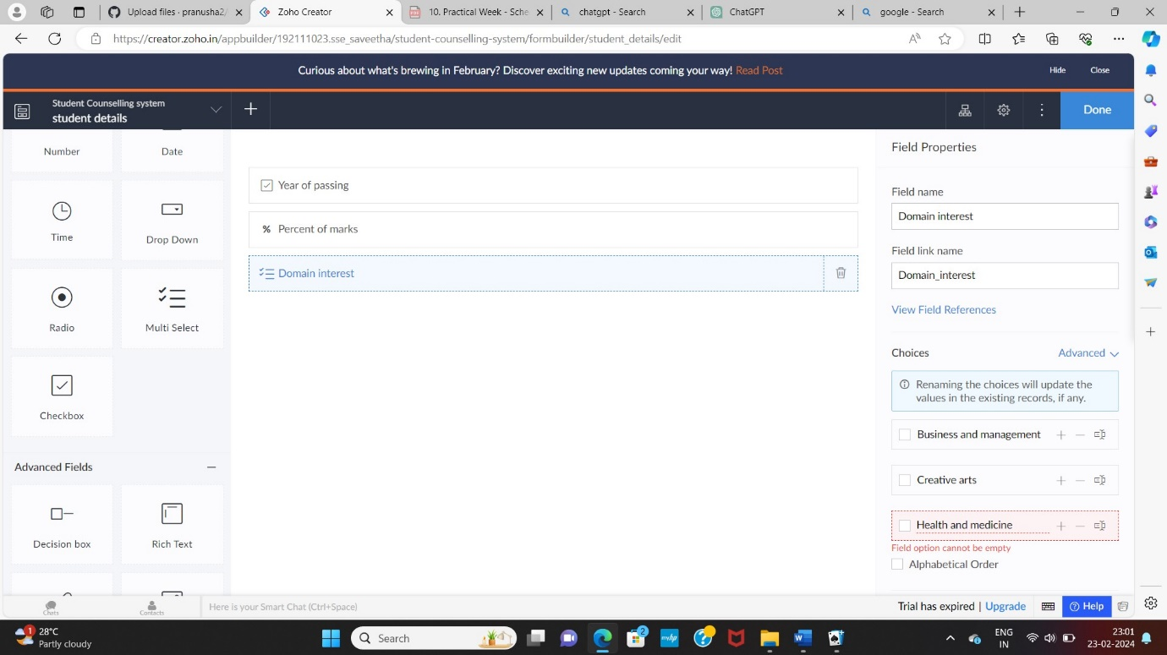

STEP 13: Click Access Development Live and enter the details to access.

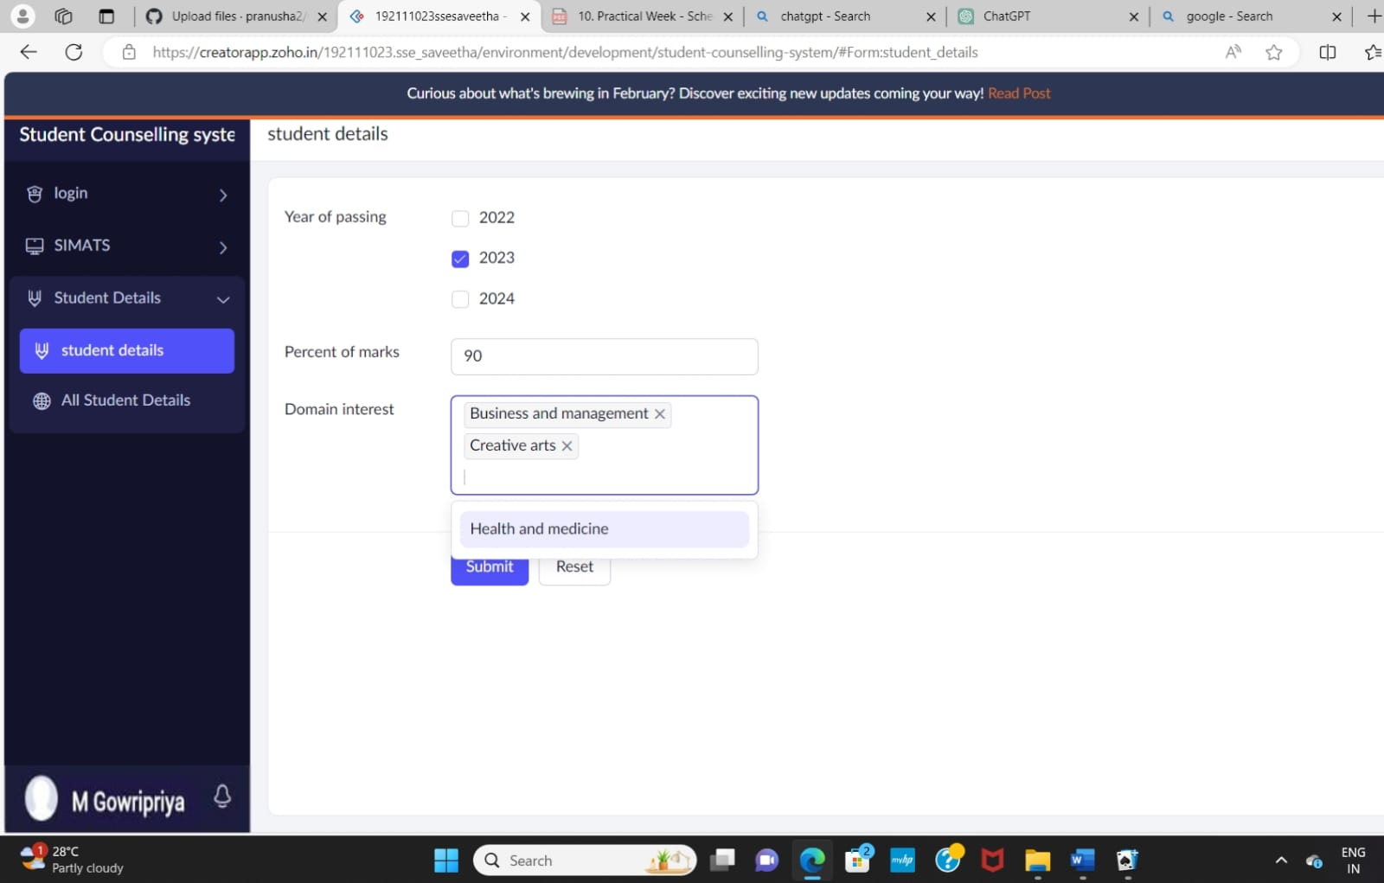

STEP 14: The report has been registered in the student details report.

